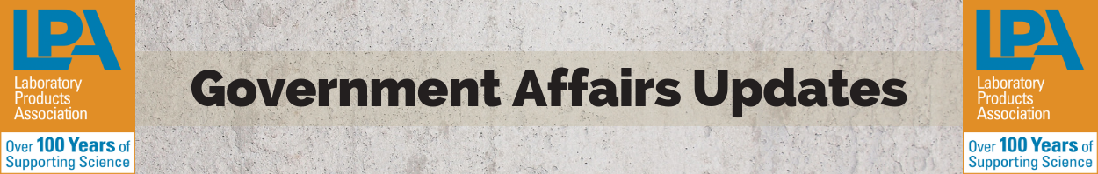
House Labor HHS Appropriations Subcommittee Hearing Notes
- House Labor HHS subcommittee appropriations bill would provide $2 billion more for the NIH including an across the board increase for all NIH institutes.
  - This funding will allow NIH to increase research and innovation.
- What are some of the advantages/effects of increased funding for the past 4-5 years?
  - Dr. Francis Collins (Director, NIH):
    - With more funding, there has been a lot of excitement for more innovative research and has given us insight into new treatments.
    - Investing in the next generation of researchers.
    - Ramping up technology for new treatments.
    - More Big Data and AI opportunities.
- Dr. Francis Collins specified that new funding will help NIH be sure that new generation of anti-biotics will be successful in the private sector and will reach customers.
- Research topics of interest include to the NIH include:
  - human fetal tissue, cancer research, antibiotics, autism research for those transitioning from youth to adult, and reproductive health.
- Committee Chair Rosa DeLauro stressed that money funded by congress needs direction from the NIH in order to fund projects that will work.
  - The dollars will follow recommendation of science conducted by the NIH institutions.
- Dr. Collins:
  - All NIH institutes have been asked to provide the most innovative options to solve the opioid crises.
- Committee Chair DeLauro:
  - What innovative research would you like to be funded for you to pursue?
    - Dynamic testing
    - More research on how to restore health, recover from being sick, physical resilience
    - Advancing analysis to make information for useful for society
    - Just-in-time gene therapy = customized gene therapy in a short amount of time
    - More brain research

